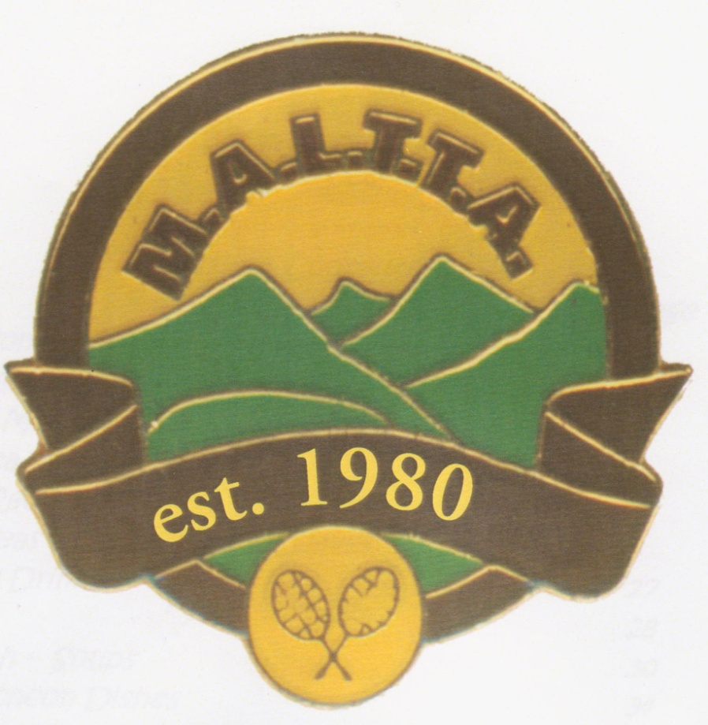
The Mountain Area Ladies Tuesday Tennis Association

Invitation
to all
who: Lady Tennis Players
past & present
{especially from previously-participating clubs}
when: Tuesday 22nd June 2021
12 midday

where: Dorset Gardens Hotel Bistro,
Dorset Road, Croydon
refer Dorset Gardens Hotel website
for Menu options

what: Reunion Get-to-gether for all
present and past players
over Lunch
how: everyone pays for their own meal

RSVP: Each club to contact Cheryl with numbers on 0421 354 236 by 15th June.
Batterham Park
Bayswater
Belgrave
Belgrave Heights
Boronia
Burnt Bridge
Chirnside Park
Croydon
Croydon Church of Christ
East Croydon
Emerald
Ferntree Gully
Ferny Creek
Gracedale Park
Healesville
Heathmont
H E Parker Reserve
Hoddles Creek
Kalorama/Mt Dandenong
Kilsyth
Knox Club
Knoxfield
Launching Place
Lilydale
Manchester Heights
Miller Park
Monbulk
Mooroolbark Heights
Mountainvale Indoor
Mount Evelyn
Mountaingate
Montrose
Montrose Terrace
Montrose Reserve
Ringwood Catholic
Seville
Selby
Steels Creek
St John the Baptist
Templeton
Upper Ferntree Gully
Upwey South
Upwey Tecoma
Wandin
Wandin East
Wantirna South
Warburton
Woori Yallock
Yarra Glen
Yarra Junction
Yellingbo

